COURT SECURITY OFFICER JOB FAIR

When: Saturday December 1, 2021 from 2:00 p.m. to 6:00 p.m. Where: FOP Lodge #1, 711 4th St. NW, Washington, DC
Application assistance available and interviews held on site. Management members will be available to answer questions regarding Paragon Systems and the Court Security Officer Program

POSITION SUMMARY: Qualified applicants must meet the criteria below.
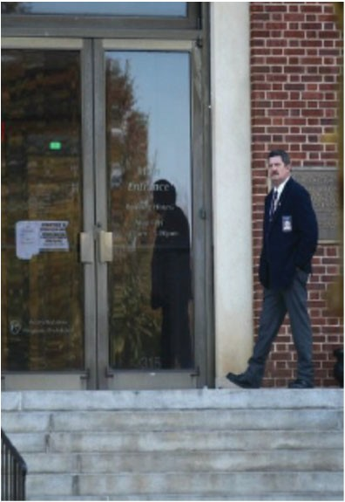
- U.S. Citizenship
- Be 21 Years of Age with Clean Credit
- Graduated from an accredited Military or Civilian Law Enforcement Academy
- 3 Years of Law Enforcement Experience with General Arrest Authority
- Be in Good Physical Health
Multiple well paid opportunities ($73,112 to $75,192 annually with an additional $10,192 in H&W) in Washington, DC due to increased staffing requirements by the U.S. Marshals Service.

Applicants should bring the following with them if possible:

- U.S. Passport or Birth Certificate
- Driver’s License
- Law Enforcement Academy Certificate or Transcript
- High School Diploma
- Social Security Card
- Cancelled Check (for direct deposit enrollment

Integrity * Vigilance * Compliance

• 703.935.4258 (tel.) • 571.758.5712 (fax)
  - https://careers.parasys.com/details/71843068163/382711/USMS‐‐‐Court‐Security‐Officer

EOE/M/F/VET/Disabilities Employer
VEVRAA Federal contractor * priority referrals for protected veterans* We participate in the E‐Verify Employment Verification Program
VA License Number: 11‐4665

